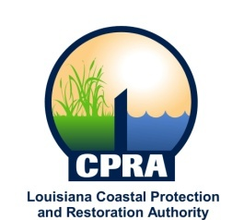

2018 Public Meetings

Johnny Bradberry, Chairman of the Coastal Protection and Restoration Authority, and Executive Assistant to Governor John Bel Edwards for Coastal Activities has announced the public meetings schedule for the Coastal Protection and Restoration Authority and the Governor’s Advisory Commission on Coastal Protection, Restoration and Conservation. Details on each meeting will be sent out at a later date. The dates and locations of these meetings are subject to change

CPRA
January 17, 2018
Baton Rouge, LA

February 21, 2018
Baton Rouge, LA

March 22, 2018
New Orleans, LA

April 18, 2018
Baton Rouge, LA

May 16, 2018
Baton Rouge, LA

June 20, 2018
Baton Rouge, LA

July 20, 2018
Lafitte, LA

August 15, 2018
Baton Rouge, LA

September 19, 2018
Baton Rouge, LA

October 24, 2018
Cameron, LA

December 12, 2017
Baton Rouge, LA

Governor’s Advisory Commission
January 23, 2018
Baton Rouge, LA

March 28, 2018
Lake Charles

June 13, 2018
Baton Rouge, LA

August 20, 2018
New Orleans, LA

November 19, 2017
Baton Rouge, LA

